2022 Get Ready Queensland Resilient Australia Awards

Newsletter copy example

We want to find, share and celebrate the amazing efforts of Queenslanders in the face of natural disasters and the COVID-19 pandemic with the 2022 Resilient Australia Awards. Help us by nominating a business, community group, school, council or government initiative that has helped Queenslanders prepare for, get through, and recover after, a natural disaster.

Entries in 2022 can also include responses to the COVID-19 pandemic. We know there have been extraordinary responses from across Queensland, small and large, that have kept spirits up and the wheels of society turning during disasters.

Queensland winners are announced at the Queensland awards in September, before they go onto the national awards in November. Find out more, enter or nominate someone else at https://www.aidr.org.au/programs/resilient-australia-awards/

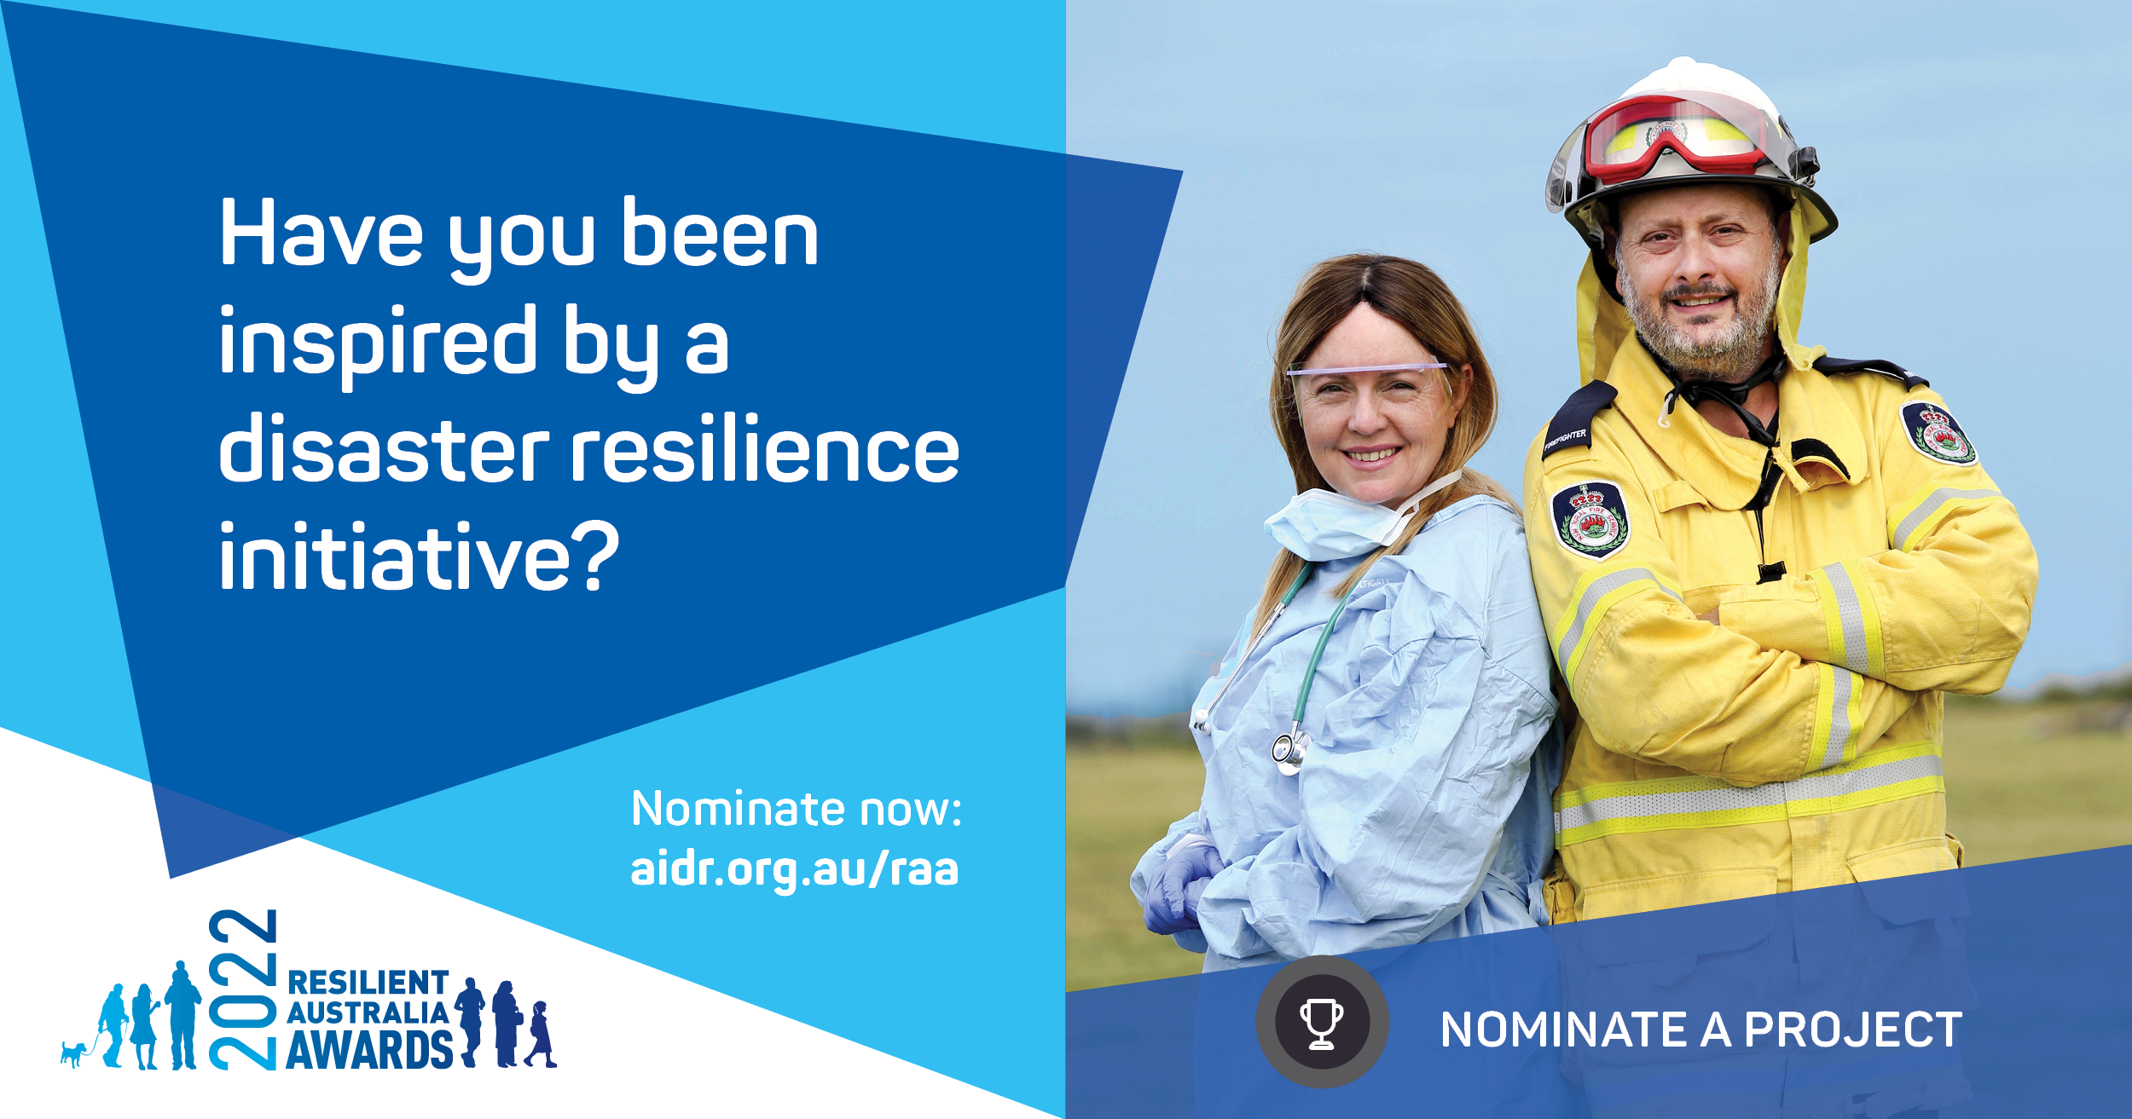

Social media examples

2022 Get Ready Queensland Resilient Australia Awards

Option 1:

Queenslanders are invited to nominate for the 2022 @Get Ready Queensland Resilient Australia Awards!

It’s a chance to showcase the great work being delivered across the state to build community resilience.

There are seven categories in this year’s awards including community, business, government, local government, school, photography, and mental health and wellbeing.

For more information, or to nominate, go to www.aidr.org.au/raa #RAA22

Option 2:

The @Get Ready Queensland Resilient Australia Awards are back for 2022!

The awards celebrate inspiring stories of community resilience. The @Get Ready Queensland team would love to hear how you are building disaster resilience in the community.

Entries are open for businesses, schools, governments, communities, local governments and photographers.

To enter go to www.aidr.org.au/raa #RAA22

