Local flood content templates

The Local flood content templates have incorporated LGA feedback to assist the development of locally specific flood communications. These templates are a resource to support localised flood messaging that can be pre-produced and on-hand for quick publication before, during and after flood events.
Councils are encouraged to add to or amend the suggested templates as appropriate through their own approval processes for more localised messaging.
A series of social media tiles have been developed to accompany these suggested templates; however, councils are encouraged to use their own local images as appropriate. The social media tiles can be found on the Get Ready Queensland Council Hub website.
The following templates cover a wide range of topics identified by LGAs as locally relevant to flooding.
- Flood signs  - Sirens and siren testing  - Flood cameras  - Flood cameras maintenance / out of order  - Local flood gauges  - Early warning alert system  - Volunteers  - Disaster dashboards  - Flood awareness  - Flood types  - Flood mapping | - Local geography and catchment conditions  - Reconstruction Monitoring (RM)  - Sandbags – collection / own supply  - School closures  - Public safety – Road conditions  - Public safety – Road closures  - Roads closed from flash flooding  - Public safety – sports grounds  - Public safety – closure parks  - Know your neighbours  - Green waste  - Kerbside collection clean-up

Flood Topic | Template Content | Template Graphic
Flood signs | Show me a sign!  Flood signs and gauges tell you when floodwater has made an area unsafe. Do you know what to look out for?  Keep an eye on local conditions and follow road closed or no entry signs. You can also plan ahead by using our Disaster Dashboard [insert link]  Stay informed and always prepare for flooding. | 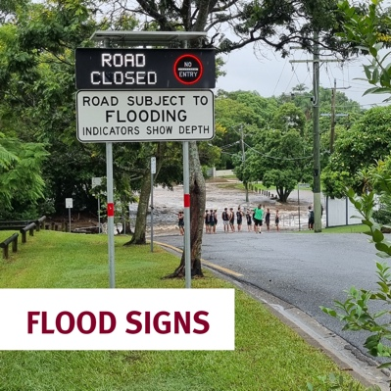
Sirens and siren testing | [insert location] FLOOD WARNING SIREN TEST  This is a friendly reminder that on [insert day/date] at [insert time] council will TEST the [insert location] Warning Siren.  YOU DO NOT NEED TO ACT. This is a TEST ONLY.  Sirens alert the community to significant safety risks including loss of life.  In a real flood, don’t wait to hear the siren. Plan to leave early if needed.  Visit [insert link] for more information. | 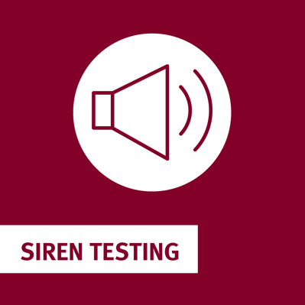
Flood cameras | Take a peep!  Our flood cameras are always keeping an eye on things… and you can too!  Flood cameras help us see flood levels in key locations. They are very useful when [insert location] weather turns.  Our flood cameras are located [insert location]  Find out more at [insert link] | 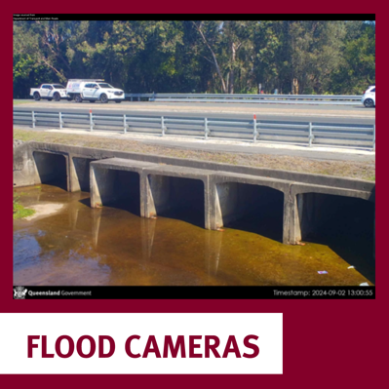
Flood cameras maintenance / out of order | Flood Camera Update  For the next [insert timeframe], we'll be switching off all Flood Monitoring Cameras.  Flood cameras provide us with early flood warnings and data for responding organisations via our Disaster Dashboard [insert link]  The cameras should be back online around [insert time and day], so stay tuned for updates.  Thanks for your cooperation. | 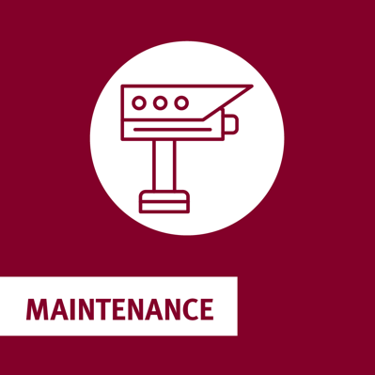
Local flood gauges | Did you know that you can now monitor your local water levels in near-real-time?  Stay ahead of potential flooding with our flood warning map and gauge readings [insert link]  Keep a watchful eye on your local conditions. | 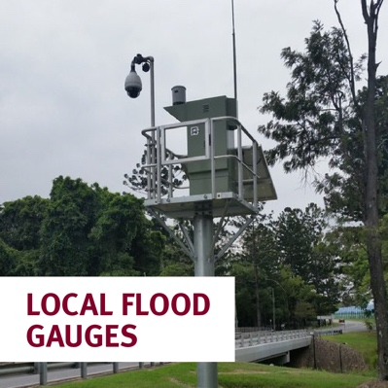
Early warning alert system | Sign up to our early warning alerts!  [insert name of alert] is a free SMS, email, and voice alerting system.  Get alerts for severe weather warnings, bushfire warning messages and flash flooding incidents, [insert other events]  Visit [insert link] to register and get prepared today. | 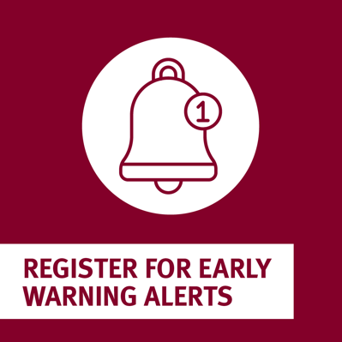
Volunteers | Are you are interested in volunteering to help people in your community impacted by floods?  Register or update your details at Emergency Volunteering now!  You can also call Volunteering Queensland on 1800 994 100 for more information.  Whether you volunteer on the frontline or behind the scenes, you can be a local hero and help Queenslanders most in need.  Visit [insert link] for more information. | 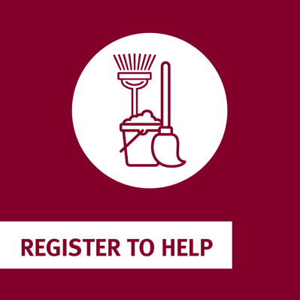
Disaster dashboard | Our Disaster Dashboard is waiting for you!  [Council name’s] dashboard is where you find local information before, during and after extreme weather, like storms and floods.  It has essential information including:  [insert information]  [insert information]  Check it out and get the lay of the land [inset link] | 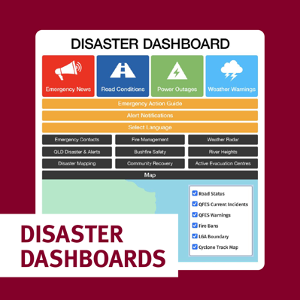
Flood awareness | Always prepare for floods.  Even when the weather is hotter and drier, [insert location] can still get intense rain that can cause flooding.  One way you can stay prepared is by registering for weather warning notifications.  Sign up for [insert council name’s] notification service or find out about the Bureau of Meteorology’s warning notifications here: www.bom.gov.au/app | 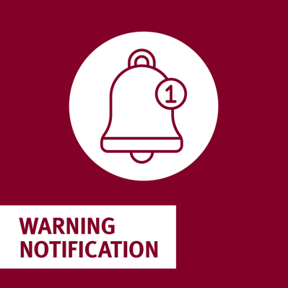
Flood types | What do “riverine”, “flash” and “storm surge” all have in common?  Answer: They are all types of floods.  Flooding in [insert location] can happen anytime and disrupt how you live, work, play and move in your community. It is important to think about how floods can impact you and your family.  Learn more about types of floods and tips to prepare at getready.qld.gov.au or [insert local link] | 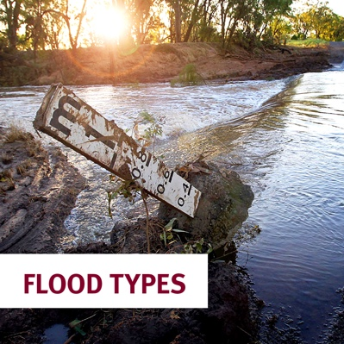
Flood mapping | How could flooding upset your life?  Floods can disrupt more than just your home. Flooding can get in the way of your work, school or even holiday plans.  Use [insert council name] flood mapping to check out where flooding might get in the way of you and where you’re going.  If you can’t view our maps online, we have copies you can pick up at [insert location]  Think ahead and always prepare for flooding! | 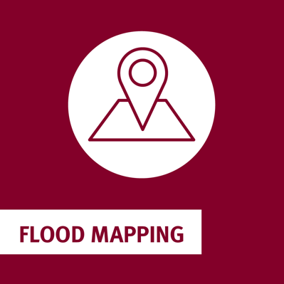
Local geography and catchment conditions | Be prepared for possible flooding!  Issued at [insert add time, day, date]  The following river catchments are likely to be affected:  [insert rivers - including various creeks and tributaries]  [insert creeks]  If you live or work near rivers and creeks, keep an eye on weather forecasts and warnings.  Stay tuned for updates at [insert link]
Reconstruction Monitoring (RM) | Attention [insert location] residents!  Queensland Government will be visiting our community on [insert date] to assess homes and businesses that were impacted by the [insert date/year] floods.  Reconstruction Monitoring (RM) is an important part of community recovery to make sure all residents are supported after floods  Not home when they visit? They’ll leave a calling card with contact information.  For more information visit www.qra.qld.gov.au/reconstruction-monitoring | 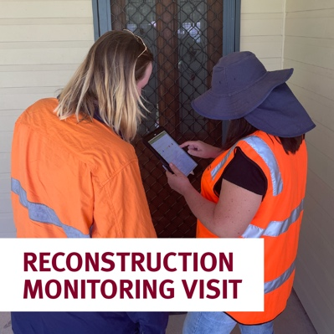
Sandbags – collection/  own supply | Come and grab your sandbags!  We have them available for you at [insert time/date/day from location]  You can also fill sandbags yourself.  Sandbags are a simple yet effective way to help reduce the impact of flooding and protect your property.  Find out more at [insert link] | 
School closures | SCHOOL CLOSURES DUE TO FLOODING  Here is the list of schools that will be closed due to flooding:  [Insert school]  Visit the Queensland school closures website for the latest information about schools in affected areas [insert link]  Stay up to date with the weather conditions on our Disaster Dashboard [insert link] | 
Public safety - Road conditions | FLOODING ROAD CONDITIONS  Heavy rainfall over the past few days has caused some localised flooding on several roads.  Please reconsider travel. Remember if it’s flooded, forget it.  Download QLD Traffic app to stay in the know https://qldtraffic.qld.gov.au/more/index.html  If you see a flooded road or require emergency assistance, please contact [insert link] | 
Public safety - Road closures | FLOODING ROAD CLOSURES  The following roads have been temporarily closed for your safety:  [insert information]  Please reconsider travel. Remember if it’s flooded, forget it  Download QLD Traffic app to stay in the know https://qldtraffic.qld.gov.au/more/index.html  If you see a flooded road or require emergency assistance, please contact [insert contact details] | 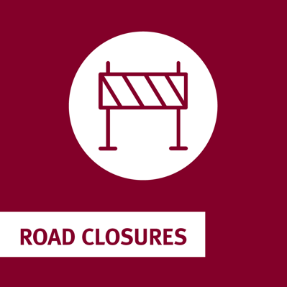
Roads closed from flash flooding. | Flash Flooding ROAD CLOSURES-ISSUED [insert date and time]  Due to flash flooding and sudden rises in water levels the following roads are closed until further notice.  [insert road]  [insert road]  Do not to attempt to drive through floodwater and obey road signs.  Remember, if it’s flooded, forget it.  For updates on local council roads visit our Disaster Dashboard [insert link] | 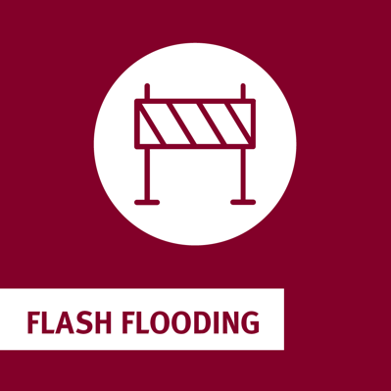
Public safety – sports grounds | SPORTS GROUNDS CLOSED  Due to current weather conditions and heavy rainfall, we’re sorry to inform you that [insert sportsground] will be CLOSED [insert dates]  No training or games are to be conducted on any of the fields for safety reasons.  Visit [insert link] for updates.  Stay safe and let's hope for better weather conditions in the coming days! | 
Public safety – closure parks | PARK CLOSURES  Due to current weather conditions and heavy rainfall, we’re sorry to inform you that the following parks will be CLOSED until further notice:  [insert park]  BBQ facilities at the following locations have been TURNED OFF:  [insert location]  Stay tuned for further updates at [insert link]  Please stay safe during the wet weather. | 
Know your neighbours | Get to know your neighbours!  We do better when we know the people in our community especially when extreme weather hits.  - Say g’day and introduce yourself  - Have a barbecue or street party  - If you have pets or kids, try a play date  - Chat about weather – share local knowledge about flooding  - Make your neighbours apart of your emergency plan  Find other ways to connect to your community at [inset link] | 
Green waste | FREE GREEN WASTE DISPOSAL  Clean up and recovery efforts have started!  Starting on [insert day/date], we are providing FREE green waste disposal at Council's transfer stations.  This is available to ALL residents.  Here are the locations of our transfer stations:  [insert location]  For more about green waste, visit [insert link] | 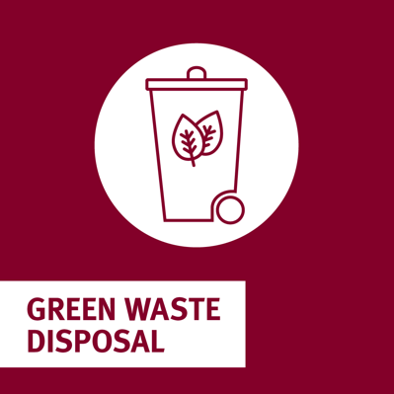
Kerbside collection clean-up | FLOOD WASTE CLEAN-UP  Clean up and recovery efforts have started!  We are organising kerbside clean-up operations from [insert date]  To make sure your items, debris, and waste are collected, please place them on your kerbside by [insert date]  Do not collect other people’s items. This can be a health and safety issue as items can be contaminated from flood water.  For more about the flood waste clean-up, visit our website [insert link] | 

